Date | 30 September 2026
Team ID | 6ab4dd7a6f290be8a6b49f92
Project Name | Script-Controlled ACL – Restrict Record Access Based on Field Value
Maximum Marks | 3 Marks

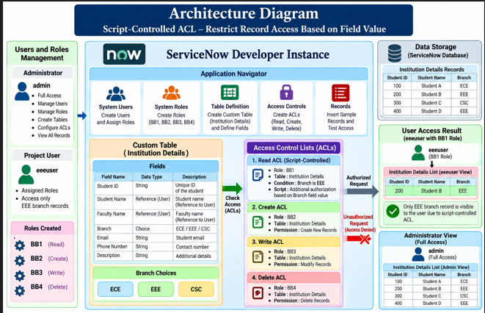

The Architecture Diagram illustrates the overall structure of the proposed ServiceNow security solution. The system is implemented in a ServiceNow Developer Instance, where users and roles are managed and assigned appropriate permissions. The Institution Details custom table contains student information and branch values such as ECE, EEE, and CSC. Access Control Lists (ACLs) are configured for Read, Create, Write, and Delete operations, with the Read ACL using a script-based condition to verify the Branch value. As a result, the configured project user can access only the authorized EEE record, while the administrator retains full access to the Institution Details records.

